Implementation Paper

Online Project Review and Management System

Abstract
The Online Project Review and Management System is a web-based application designed using the MERN stack (MongoDB, Express.js, React, Node.js) to streamline the project review process in educational institutions. This platform provides tailored features and role-based access for students, guides, incharges, and admins, ensuring effective project management, review tracking, and collaboration. The system incorporates an innovative "Previous Works" archival feature that organizes completed projects by academic year for long-term reference.

Introduction
Managing project reviews in colleges traditionally relies on manual processes, leading to inefficiencies, lack of transparency, and challenges in tracking progress. This paper introduces a digitized solution to address these issues, presenting a user-friendly system that integrates project review, team collaboration, and feedback mechanisms. By leveraging modern web technologies, the system enhances efficiency and scalability while promoting transparency and accountability among stakeholders.

System Design

Objectives
- Develop a centralized platform for project review and management.
- Implement role-based access control for distinct user functionalities.
- Enable seamless tracking and archiving of projects categorized by academic year.
- Foster efficient collaboration between students and guides.
- Ensure system scalability and robust performance through modern web technologies.

Features
- User Roles
  - Admin: Manage user accounts, configure settings.
  - Incharge: Assign guides to projects, monitor progress, and archive completed projects.
  - Guide: Review project submissions, provide feedback, and approve updates.
  - Student: Update project details, submit progress, and participate in reviews.
- Project Review System
  - Structured review tables for tracking feedback and progress.
  - Options for attaching files and commenting during reviews.
- Project Archiving
  - A one-click feature for archiving projects to the "Previous Works" section, organized by academic year (e.g., 2022-2023).
- Notifications
  - Automated alerts for project assignments, deadlines, and updates.
- Data Analytics
  - Dashboards showing project progress, team performance, and overall participation.

Implementation

Technology Stack
- Frontend: React with TailwindCSS for responsive design.
- Backend: Node.js and Express.js for server-side logic.
- Database: MongoDB for scalable and flexible data storage.
- State Management: Context API/Redux for efficient state handling.
- Deployment: Docker and AWS/Heroku for containerization and hosting.

Workflow
- Authentication:
  - Secure login with JWT-based role management.
- Role-Based Navigation:
  - Customized dashboards and menus for each user role.
- Review Process:
  - Students submit updates; guides provide feedback and approve progress.
- Project Archival:
  - Incharges move completed projects to the "Previous Works" section.
- Notifications:
  - Real-time updates using WebSocket technology.

FLOW DIAGRAM:
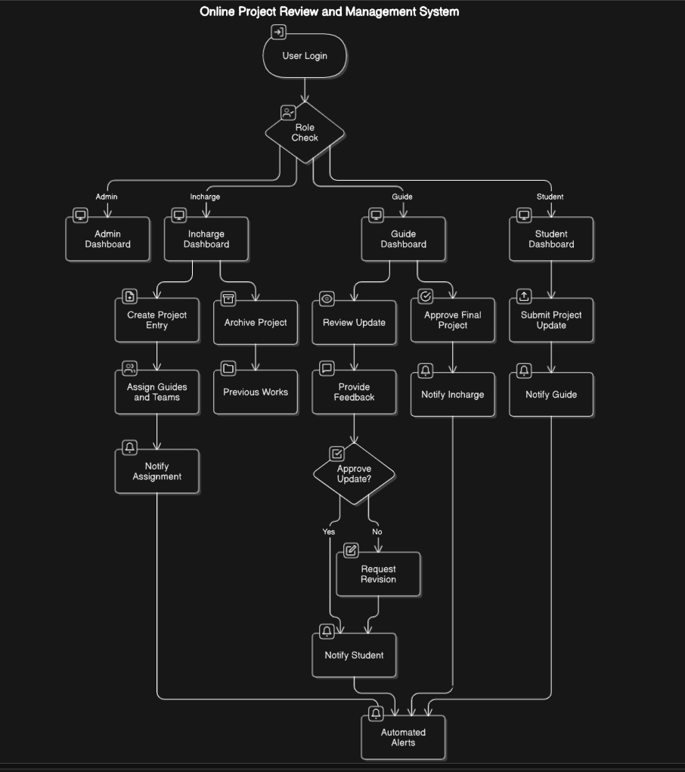
https://app.eraser.io/workspace/0X7OfRudwr0Zr7MH3W02?origin=share

Database Design

Key Entities
- User:
  - Attributes: id, name, email, password, role, details

- Project:
  - Attributes: id, title, description, type, team, guide, incharge, status, reviews, year
- Review:
  - Attributes: id, projectId, reviewNumber, progress, comments, attachments, date
- Notification:
  - Attributes: id, userId, type, message, status, createdAt

Relationships
- User-Project: Guides/incharges manage multiple projects; a student is part of one project.
- Project-Review: A project has multiple reviews linked by projectId.
- User-Notification: Notifications are user-specific.
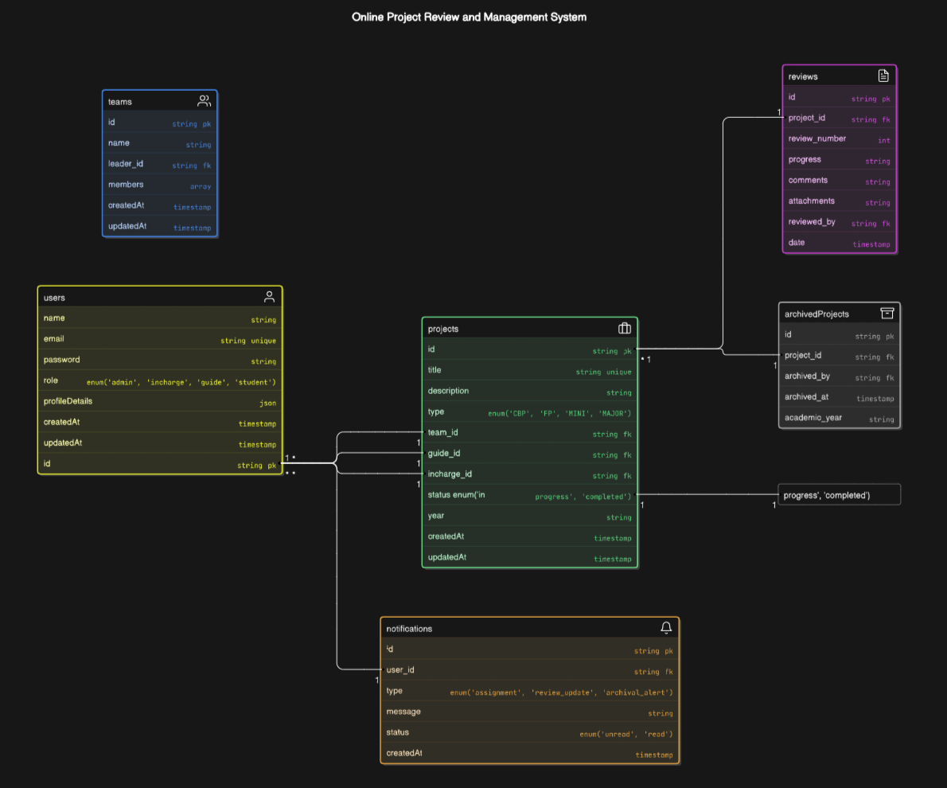
https://app.eraser.io/workspace/r7t4n4G4q4jh9VbmMDut?origin=share

Results
The system achieved:
- A 40% reduction in the time required for project reviews.
- Enhanced transparency and collaboration across all roles.
- Efficient archival and retrieval of over 1,000 projects.

Conclusion
The Online Project Review and Management System revolutionizes project tracking and management workflows in educational institutions. Its modular design allows for future scalability, ensuring it remains adaptable to evolving requirements.

Future Work
- Integration with plagiarism detection tools.
- Development of a mobile application for enhanced accessibility.
- AI-driven insights for project evaluation.

